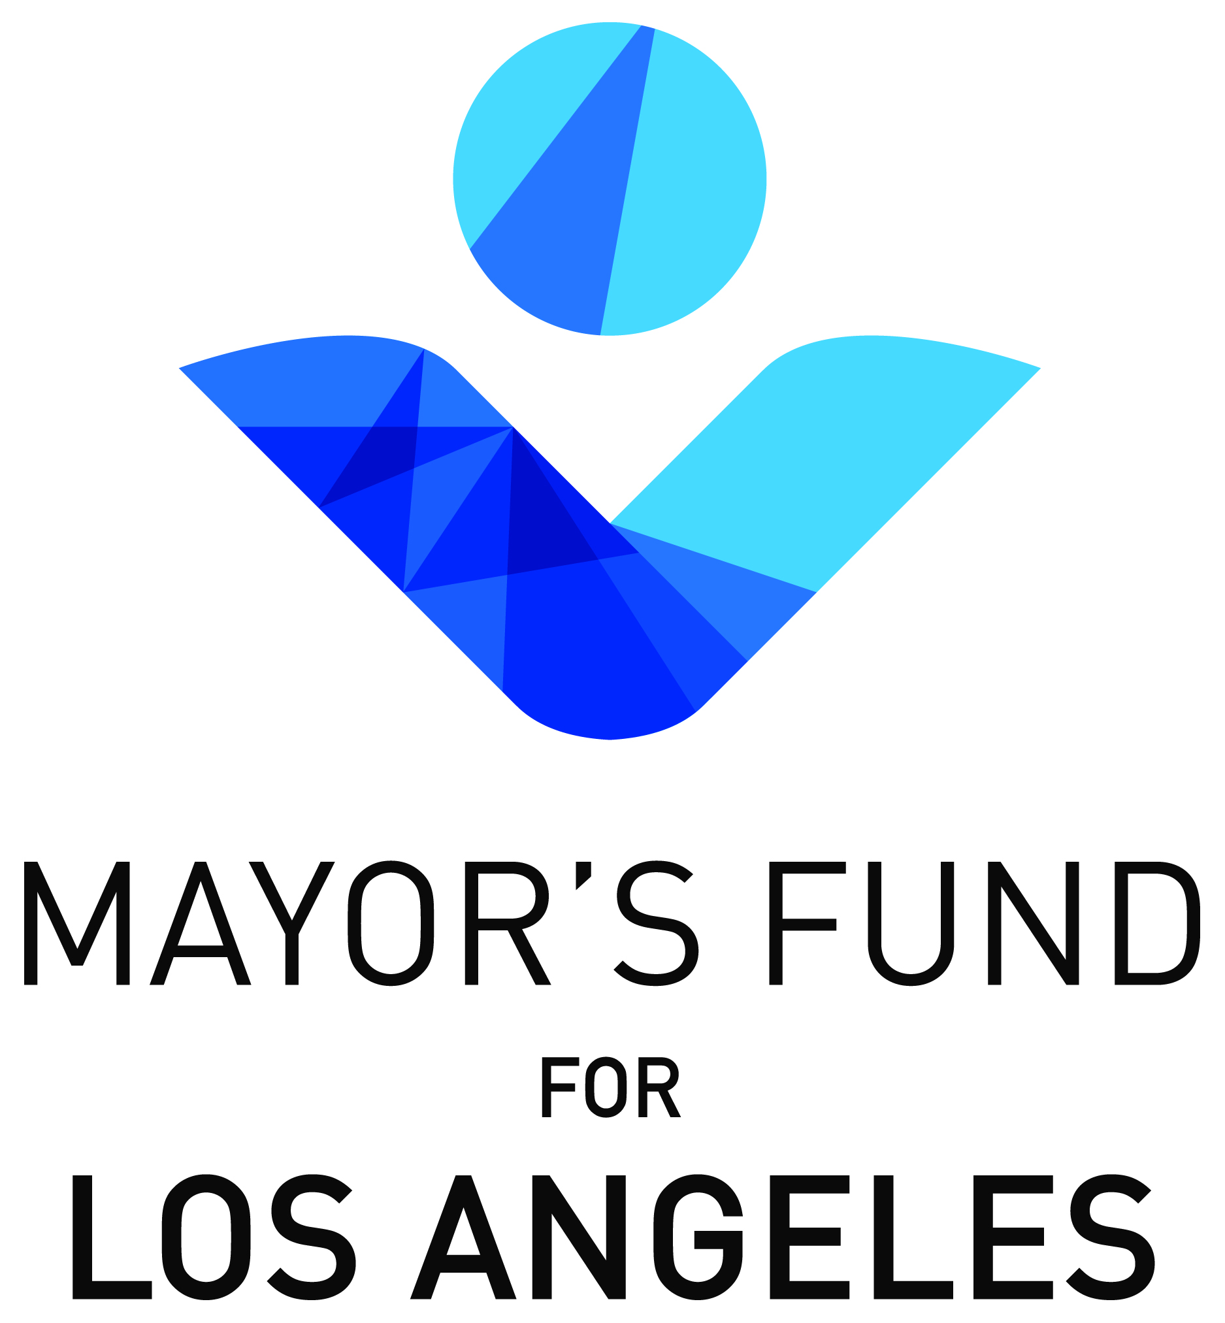
FOR IMMEDIATE RELEASE – WEDNESDAY, JANUARY 27, 2016

Contact: Josh Kamensky, 323-326-7438
joshkamensky@gmail.com

LEONARD HILL GIFT TO MAYOR’S FUND FOR LOS ANGELES WILL PROVIDE NEW SIXTH STREET BRIDGE WITH ARTS PLAZA AND PROGRAMMING

A major philanthropic gift on the part of developer Leonard Hill to the Mayor’s Fund for Los Angeles will fund the design, construction and programming of an arts plaza beneath the new Sixth Street Bridge, Mayor Eric Garcetti announced today.

The $1.9 million gift will ensure the realization of the recreational and community-building components included in the city’s vision for the new Sixth Street Bridge. The proposed Leonard Hill Arts Plaza, pending City Council approval, will sit underneath the bridge between Santa Fe Avenue and the Los Angeles River. The gift includes funding for the design and construction of a stage as well as funding for a performing arts series that will be open to the public. The Plaza is expected to be constructed in 2019 and begin arts programming in the space in 2020.

"For too long Los Angeles has been thought of as urban sprawl without a center. With the construction of the new 6th Street bridge we begin to create a meaningful and monumental city center,” said Leonard Hill. “The remarkable growth of our downtown metropolis will be anchored by this architecturally stunning and internationally renowned 6th Street bridge. I am proud to be part of the effort to create it.”

Hill, a founding partner of Linear City Development, as well as a native Angeleno and a longtime television producer, helmed such notable developments as the Toy Factory Lofts and Biscuit Lofts residential adaptive reuse projects, both linchpins in the renewal of the Downtown Los Angeles Arts District neighborhood.

“It takes vision and leadership to create a legacy,” said Mayor Eric Garcetti. “Just as the Sixth Street Bridge has connected the neighborhoods to the east and west of the L.A. River, Leonard’s incredible gift will give future generations of Angelenos a beautiful place to connect with the outdoors, their communities, and each other.”

“The Mayor’s Fund for Los Angeles is incredibly grateful to Leonard Hill for his donation,” said Deidre Lind, the Fund’s President. “The arts plaza will ensure arts remains a cornerstone of neighborhoods connected by the Sixth Street Bridge. Mr. Hill’s generosity demonstrates the value of public-private partnerships as we look to the future of Los Angeles. The Fund was created for exactly this purpose – to facilitate philanthropic visions that dovetail with the work being done by city government, and to encourage the private sector to step up as a partner with the public sector.”

The iconic Sixth Street Bridge, its concrete deteriorated beyond repair, is scheduled for demolition in early in 2016. The new bridge, designed by HNTB and Michael Maltzan, is scheduled to be completed in 2019.

-- ### --

About the Mayor’s Fund for Los Angeles
The Mayor’s Fund for Los Angeles is a non-profit, non-partisan organization dedicated to improving life for all Angelenos. Bringing together institutions and experts from across the City, the Fund supports programs that will create transformative change across Los Angeles, making it a world leader in economic prosperity, government efficiency, community resiliency, and quality of life for all of its residents. Uniquely positioned at the crossroads of local government, business, philanthropy, and non-profits, the Fund enables communication and collaboration that will tackle some of Los Angeles’ most complex challenges. The Fund is supported by private donations and is overseen by an independent Board of Directors. More information can be found at www.mayorsfundla.org.

