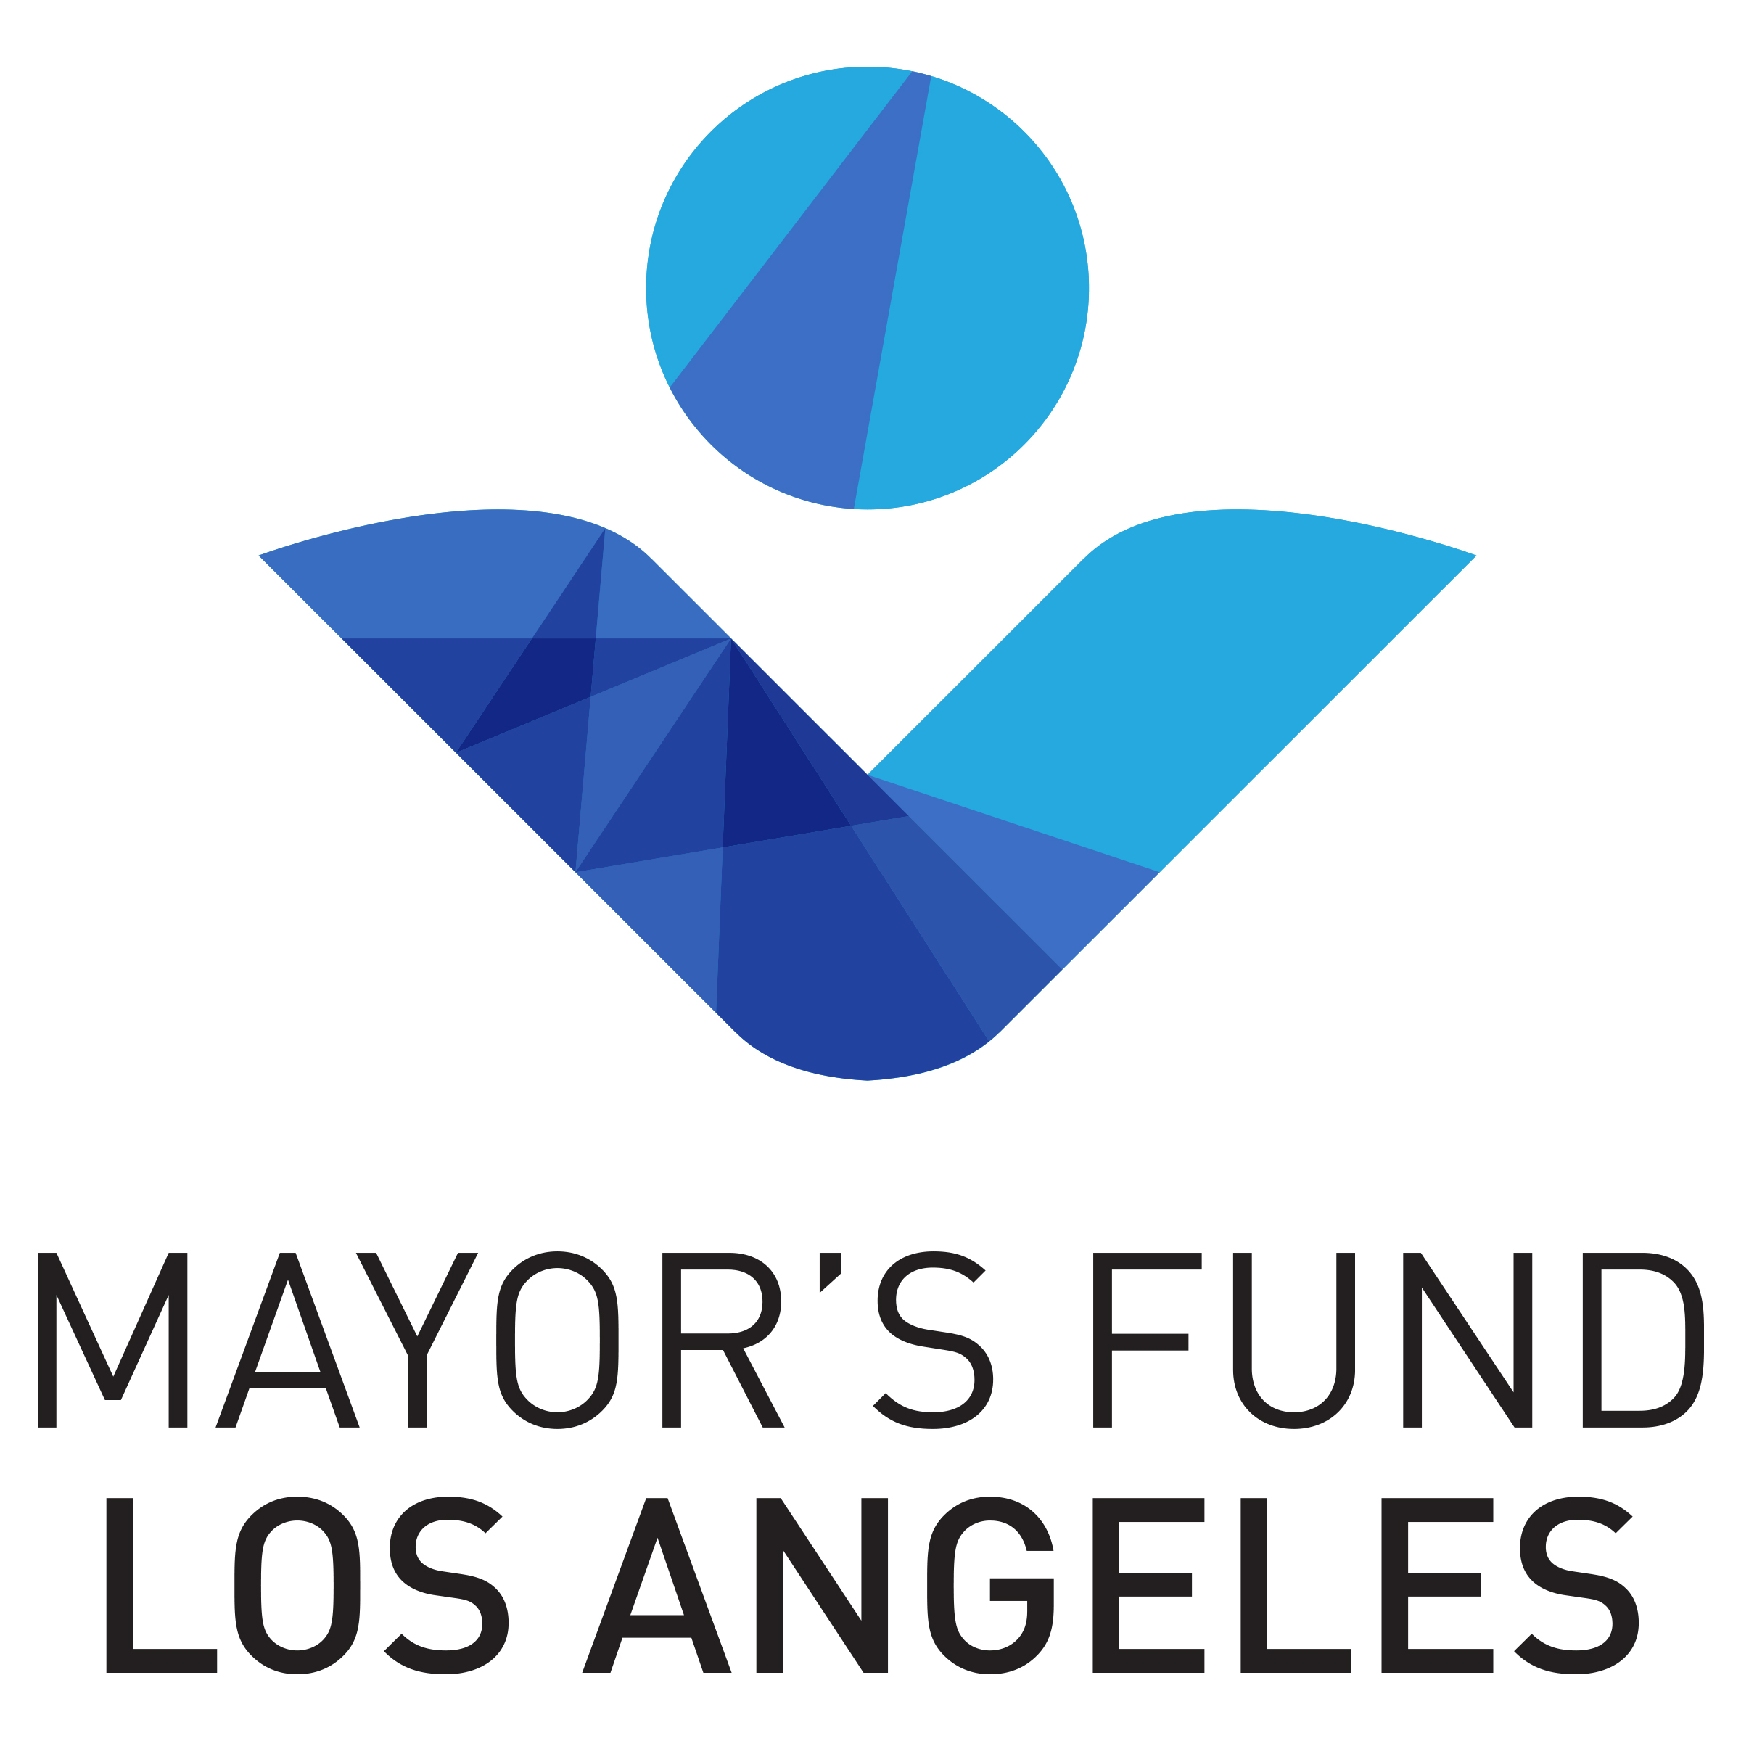

FOR IMMEDIATE RELEASE
April 22, 2015

Contact: (213) 545-2058

MAYOR’S FUND FOR LOS ANGELES URGES ANGELENOS TO
‘SAVE THE DROP’ ON EARTH DAY

The Fund Brings Private Resources to the City’s Anti-Drought Efforts
To Help Launch Impactful Water Conservation Campaign

LOS ANGELES – With Earth Day 2015 coinciding with California's historic drought, the Mayor's Fund for Los Angeles today urges Angelenos to "Save the Drop" by finding ways to conserve water and lower their water bills at www.SaveTheDropLA.org (in Spanish at www.cadagotitacuentala.org).

"Combating this drought requires the city to put the right conservation tools in place, and then we need to connect as many Angelenos as possible with those tools. That's what the 'Save the Drop' campaign is about, and the role played by the Mayor's Fund's is critical to its ability to succeed," said Los Angeles Mayor Eric Garcetti.
“The Mayor’s Fund for Los Angeles is proud to help Angelenos 'Save The Drop',” said Deidre Lind, President, Mayor’s Fund for Los Angeles. “The Fund exists to connect private resources with civic programs to improve outcomes and strengthen our city, and water conservation is an absolute necessity during this drought."
"Save the Drop" is an unprecedented citywide water conservation campaign launched by Mayor Garcetti. It seeks to encourage conservation and connect Angelenos with incentives and tools they can use to save water.
"Save the Drop" for the first time coordinates the full spectrum of city resources -- from library information tables to bus benches to DWP bill inserts -- to create a mass communications campaign. The Mayor's Fund for Los Angeles provides key private sector support to ensure the campaign can be as effective as possible. The Fund brought the services of a branding expert, recruited the top-flight advertising agency Omelet to provide pro-bono creative design services, and obtained donations and donated ad space to expand the reach of this effort.
Fifty-percent of Los Angeles' fresh water is used outdoors, making the city's new, $3.75 per square foot lawn replacement rebate a key emphasis of the campaign.
Mayor Garcetti, in anticipation of the worsening drought, last fall announced the new lawn replacement rebate as part of an aggressive conservation executive directive that calls for a 20 percent cut in L.A.'s water use by 2017. Other conservation tools available through www.SaveTheDropLA.org include rebates on smart sprinkler systems and rain barrels. Indoors, Angelenos can take advantage of free showerheads and aerators and rebates on water efficient washing machines and toilets.
Anheuser-Busch today announced a $50,000 contribution to the Mayor's Fund that's designated for "Save the Drop," the largest such cash donation to date to this campaign.
“Managing and conserving water carefully is part of our daily routine as brewers. It’s a natural fit to join the call for communitywide action through the ‘Save the Drop’ campaign to drive change,” said Luis Cayo general manager, Los Angeles brewery, Anheuser-Busch. “Anheuser-Busch shares in this commitment to ‘Save The Drop’ while continuing to make quality beer.”

Omelet is an award-winning creative agency that generously developed the Save the Drop campaign completely pro bono.
"The drought is a key issue in our region, so it's quickly become a personal issue for us at Omelet" said Sarah Ceglarski, Senior Director of Marketing at Omelet. "We were honored to be asked by the Mayor's Fund for Los Angeles to lead the creative on this campaign, and we're thrilled that we can help do our part by donating our time and resources to this important cause."
The campaign is scheduled to continue until the fall, with radio and television ads featuring The Drop to be rolled out during the summer.
About the Mayor’s Fund for Los Angeles
The Mayor’s Fund for Los Angeles is a non-profit, non-partisan organization dedicated to improving life for all Angelenos. Bringing together institutions and experts from across the City, the Fund supports programs that will create transformative change across Los Angeles, making it a world leader in economic prosperity, government efficiency, community resiliency, and quality of life for all of its residents. Uniquely positioned at the crossroads of local government, business, philanthropy, and non-profits, the Fund enables communication and collaboration that will tackle some of Los Angeles’ most complex challenges. The Fund is supported by private donations and is overseen by an independent Board of Directors. More information can be found at www.mayorsfundla.org.
About Anheuser-Busch
For more than 160 years, Anheuser-Busch and its world-class brewmasters have carried on a legacy of brewing America’s most-popular beers. Starting with the finest ingredients sourced from Anheuser-Busch’s family of growers, every batch is crafted using the same exacting standards and time-honored traditions passed down through generations of proud Anheuser-Busch brewmasters and employees. Best known for its fine American-style lagers, Budweiser and Bud Light, the company’s beers lead numerous beer segments and combined hold 46.4 percent share of the U.S. beer market. Budweiser and Bud Light Lime Lime-A-Rita were named Brands of the Year for the Beer and the Spirits, Malt Beverages and Wine categories, respectively, by Ace Metrix® in 2014. Anheuser-Busch is the U.S. arm of Anheuser-Busch InBev and operates 15 local breweries, 17 distributorships and 23 agricultural and packaging facilities across the United States, representing a capital investment of more than $15.9 billion. Its flagship brewery remains in St. Louis, Mo., and is among the global company’s largest and most technologically capable breweries. Visitor and special beermaster tours are available at its St. Louis and five other Anheuser-Busch breweries. This year the Anheuser-Busch Foundation celebrates 40 years of contributing to communities across the country. For more information, visit www.anheuser-busch.com.
About Omelet
Omelet is a creative company that solves complex marketing problems for progressive partners, including AT&T, AmazonFresh, Coca-Cola, HBO, and Microsoft. The company also has divisions – including Omelet Studio, Omelet To Go, and Omelet Brands – to create original brand programming, live interactive experiences, and original owned intellectual property. www.omeletla.com

#######

